**CSC7056/CSC3056**

Practical

**Unit Testing**

Friday 22nd April 2016

JUnit Test the following methods. (Code supplied on QOL).

**Exercise 1**



**Exercise 2**

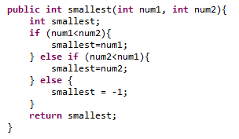

**Exercise 3**

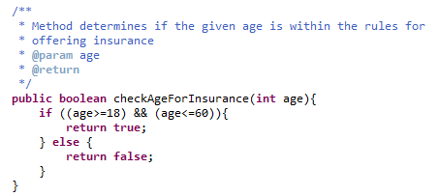

**Exercise 4**

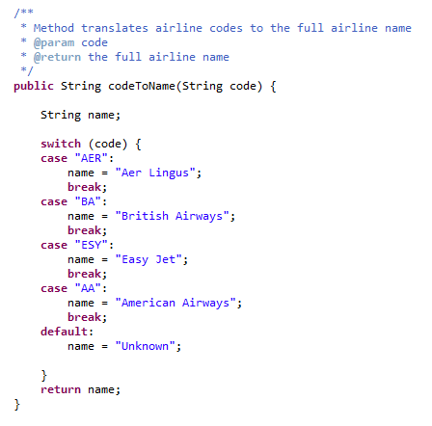

**Exercise 5**

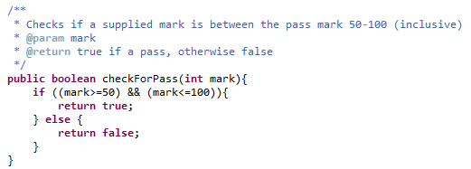

**Exercise 6**

